we have a set of students stored in a json file.

Each student model has fields like firstName, lastName and id but no fullName.

Here, we will see how to make a query to retrieve fullName of all students.

For this, we need to create fullName field in both schema resolver.

## Step 1 − Download and Install Required Dependencies for the Project

Create new package.json file with below code and install all dependencies.

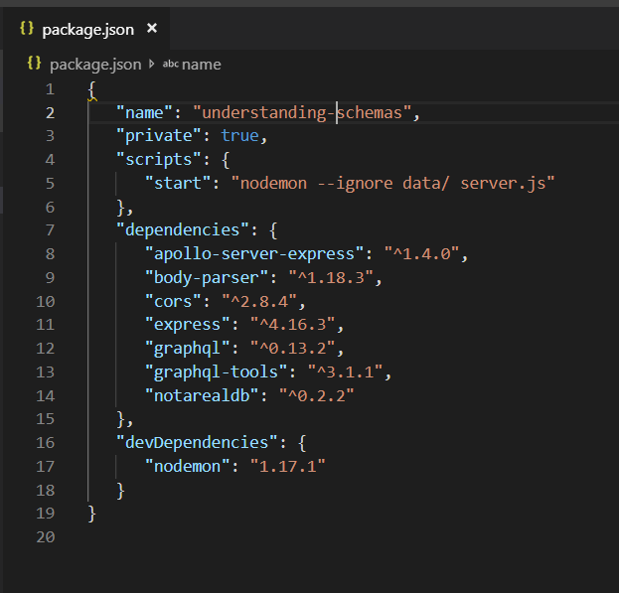

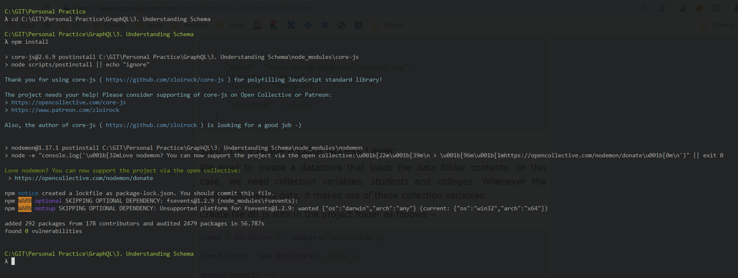

**Create Flat File Database in Data Folder**

we use flat files to store and retrieve data.

Create a folder data and add two files **students.json** and **colleges.json**.

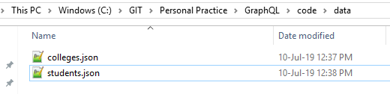

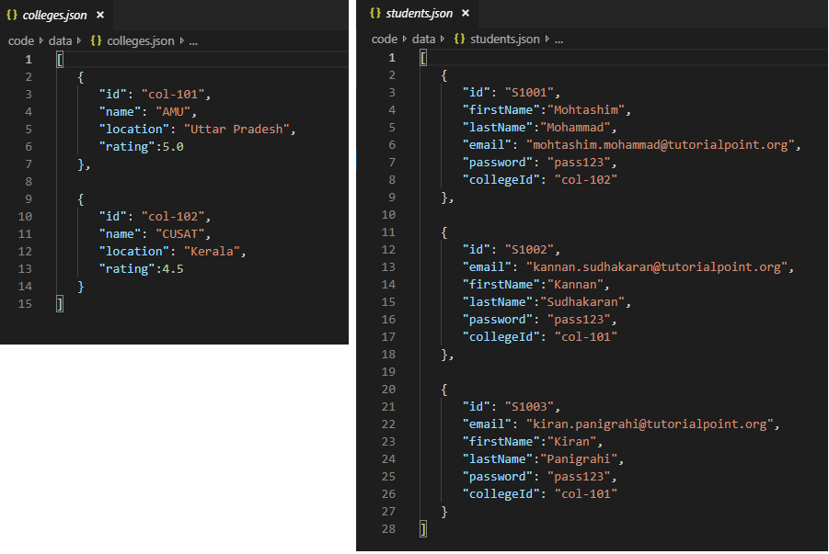

**Create a Data Access Layer**

We need to create a datastore that loads the data folder contents.

In this case, we need collection variables, *students* and *colleges*.

Whenever the application needs data, it makes use of these collection variables.

Create file db.js with in the project folder as follows

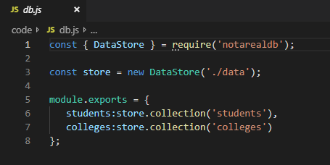

## Step 2 − Create a Schema

Add **schema.graphql** file with following code

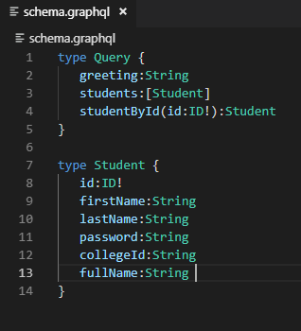

Note that there is no *fullName* field in the **students.json** file. However, we need to fetch the *fullname* of the student via a query.

The *fullName*, in this case will be a custom field that isn't available with the data source.

## Step 3 − Create Resolver

Create a file **resolvers.js** with following code

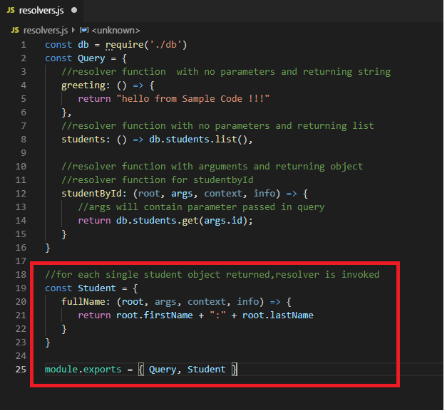

## Step 4 − Run the Application

Create a server.js file.

